**LEBANESE AMERICAN UNIVERSITY**

**USAID – HIGHER EDUCATION SCHOLARSHIP PROGRAM**

**HES - Volunteering Program Verification Form**

This form is to be used to document volunteering hours. If a student volunteers for multiple organizations, a separate form must be used for each organization. **This form must be turned in by the 28th of each month, the latest.**

I certify that the scholar Aline Ali Diab completed a total of 10 hours of service at Life Sculptor.

The hours were completed hours as per the below:

Hours # 2 (date) _30/09 – 5/10_ (initials of supervisor) __A.K.___

Hours # 3 (date) _7/10 – 11/10_ (initials of supervisor) __A.K.___

Hours # 2 date) _14/10 – 18/10 (initials of supervisor) __A.K.___

Hours # 3 date) _21/10 -25/10 (initials of supervisor) __A.K.___

Brief description of the activities the scholar performed or participated in:

Secretary of the CEO, I coordinate appointments by communicating with the CEO and the other party, as well as doing the weekly calendar for the CEO and sending emails.

Written feedback about the scholar’s performance:

Aline demonstrates excellent organizational skills as the Secretary of the CEO, effectively coordinating appointments and managing the CEO’s weekly calendar.

Please rate the overall performance of the scholar at your organization:

|  |  |  |  |
| --- | --- | --- | --- |
|  | Mastery (5) | Proficient (3) | Emerging (1) |
| **Problem solver** | X |  |  |
| **Engaged & Committed** | X |  |  |
| **Open-minded & multicultural** | X |  |  |

Signature

& stamp

__________________________

_

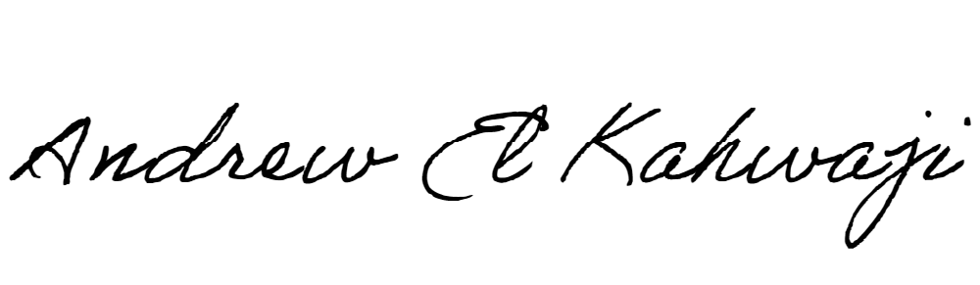

Printed Name _Andrew El Kahwaji_

Date __26/10/2024___

Email __andrew.lifesculptor.coo@gmail.com __

Phone __+961 71 914 378__

**LEBANESE AMERICAN UNIVERSITY**

**USAID – HIGHER EDUCATION SCHOLARSHIP PROGRAM**

